PERSISTENCE MAPPING USING EUV SOLAR IMAGER DATA
BARBARA J. THOMPSON¹ AND C. ALEX YOUNG²
¹ NASA Goddard Space Flight Center, Code 671, Greenbelt, MD 20771, USA; Barbara.J.Thompson@nasa.gov
² NASA Goddard Space Flight Center, Code 670, Greenbelt, MD 20771, USA; C.Alex.Young@nasa.gov

ABSTRACT
We describe a simple image processing technique that is useful for the visualization and depiction of gradually evolving or intermittent structures in solar physics extreme-ultraviolet imagery. The technique, which we call "Persistence Mapping," allows the user to isolate extreme values in a data set, and is particularly useful for the problem of capturing phenomena that are evolving in both space and time. While integration or "time lapse" imaging uses the full sample (of size N), Persistence Mapping rejects (N-1)/N of the data set and identifies the most relevant 1/N values using the following rule: if a pixel reaches an extreme value, it retains that value until that value is exceeded. The simplest examples isolate minima and maxima, and the technique has been used to extract the dynamics in long-term evolution of comet tails, erupting material, and EUV dimming regions.
1. INTRODUCTION
Many important solar phenomena have dynamic natures that make them difficult to identify and capture. In particular, features that evolve in both space and time require processing techniques that can extract the key physical attributes from increasingly large data sets. We describe a processing technique that is simple to implement, yet captures several important aspects of spatial/temporal evolution. This technique, called "Persistence Mapping," can be used on its own, or it can provide important pre-processing information more sophisticated algorithms.
For a data set consisting of N images with emissions values I(x,y,t), the Persistence Map P_{n} is a function of several arguments, namely emission, location and time:
P_{n}(x,y,t_{n})=Q(I(x,y,t≤t_{n}))
where x, y and t are the spatial and temporal coordinates, t₀ < t_{n} ≤ t_{N} are the image sampling times, and Q is the selection function. The most common (and simplest) forms of Q are minimum and maximum values. For a maximum value Persistence Map (such as the one shown in Figure 3), P_{n}(x,y,t_{n}) represents the maximum value of the location (x,y) evaluated for the time range t₀ (first image) to t_{n} (current image). Similarly, minimum value Persistence Maps are shown in Figures 7, 9, 10 and 11.
While Persistence Maps can capture the evolution of a feature over time, the technique is different from averaging or "time-lapse" integration in that it chooses a single data value to represent location (x, y) for all times up to t_{n}. If the desired feature or phenomenon is rare or intermittent, averaging or integrating a large data set can significantly decrease the signal relative to the background. The distinction is particularly important when the number of images N becomes large compared to the number of times the feature is observed at a given location; if the feature is only present at location (x, y) for one image, Persistence Mapping discards the information from the other N-1 images.
Of course, the degree of success yielded by the Persistence Mapping technique depends on the ability to optimize the mapping function Q for a particular feature or phenomenon; not all solar features consistently exhibit clearly identifiable extremes such as minima and maxima. In the next section we present several examples of solar phenomena that fit this criterion, and demonstrate how Persistence Mapping can rapidly distill key characteristics from large data sets.
2. IMPLEMENTATION EXAMPLES
2.a. Maximum value Persistence Mapping of a slowly evolving feature: Comet Lovejoy
Our first example uses data from the Atmospheric Imaging Assembly (Lemen et al., 2012; Boerner et al., 2012) on the Solar Dynamics Observatory (Pesnell, Thompson & Chamberlin, 2012). The Comet Lovejoy transited the solar corona December 15 and 16, 2011, and was well observed by investigations on several solar missions. Of particular interest is the physics behind the formation of the EUV tail (c.f. Bryans & Pesnell, 2012; Schrijver et al., 2012; McCauley et al., 2013; Downs et al., 2013).
Comet Lovejoy is a particularly powerful demonstration of the persistence technique because the time history of the comet's interaction with the corona is key to understanding its behavior. Figures 1 and 2 show the late stages of the inner coronal transit of the Comet Lovejoy. The coma shows clear evolution in time, with an apparent "kink" shape developing around 00:43 UT on December 16, 2011. (The kink is most apparent in panels c and d). Figure 2 shows the same images processed with the persistence technique, where Q is the maximum value evaluated from t=0 (2011-Dec-15 at 23:00 UT) to the time of each particular image. In Figure 2 it is clear that the paths of emission trace into elongated striations, mapping back to the location of the comet near the time of the striation's initiation. The persistence technique allows the user to clearly identify the flow direction of the comet's tail emission.
The coma consists of individual cores of emitting plasma, originating at the point where the comet nucleus intersects the corona, but then spreading along the connected field lines. Note that the "kink" in the tail, that is most evident in panels b) and c) in Figure 2, corresponds to a divergence in flow direction of the emitting plasma in the corresponding panels in Figure 3.
Movie 1: Comet Lovejoy persistence movie
Figure 1. Comet Lovejoy as seen in anhelp AIA 171 Å image taken 16 December 2011 at 00:43:00 UT. Image has been wavelet enhanced.
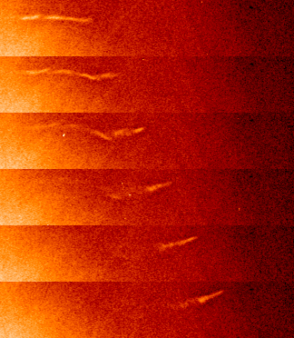
Figure 2. AIA 171 Å images sampled at 24 seconds (AIA cadence is 12 seconds) from top to bottom: 16 December 2011 at 00:43:00 UT, 00:43:24 UT, 00:43:48 UT, 00:44:12 UT, 00:44:36 UT and 00:45:00 UT. Images have been wavelet enhanced.
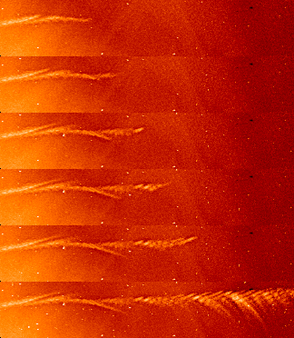
Figure 3. The images from Figure 2 processed using the persistence technique, where Q is the maximum value function for t₀<t_{n}≤t_{N} and t₀ = ??. The top 5 panels were assembled using AIA 171 Å images sampled at a 12-second cadence starting at 00:40:11 UT, up to the time corresponding to the panel. The lowest panel shows the persistence values evaluated at 00:49:00 UT (4 minutes later) to show the eventual tracks of the comet.
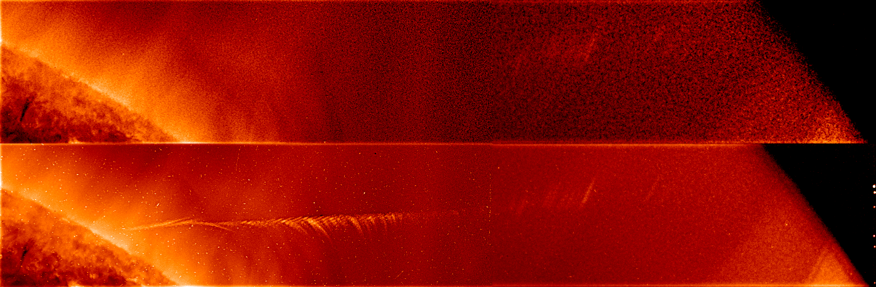
Figure 4. Top: AIA 171 Å image from 16 December 2011 at 00:57:00 UT. Bottom: Persistence image at 00:57 UT, assembled from 81 AIA 171 Å images sampled at a 12-second cadence starting at 00:40:11 UT. Both images were enhanced radially and with wavelet processing.
2.b. Minimum value Persistence Mapping of a slowly evolving feature: Coronal dimming
Movie 3: Dimming/flare/CME event of 2010 November 30 in 211,193, 171 Å 20101130_cmbmov.mov
Movie 4: Movie of 2010 November 30 dimming/flare/CME event, with 17:00 UT "base image" subtracted.
Movie 5: Persistence movie of 2010 November 30 dimming/flare/CME event with contours.
Our second example involves a coronal dimming feature that evolves slowly with time. Coronal dimmings are known to be good indicators of the site of evacuated material, and possible open field lines, during coronal mass ejections (e.g. Rust and Hildner 1976; Webb et al. 1978; Rust 1983; Hudson et al., 1996; Thompson et al. 1999; Gopalswamy and Hanaoka 1998; Reinard and Biesecker 2008, 2009). They are typically easy to identify, in that they occur in areas of relatively quiet, slowly-evolving Sun and usually persist for at least one hour.
However, dimmings can extend far from the erupting region, and are sometimes patchy in appearance, with some areas reaching their lowest emission value long before separate but apparently related areas. An important aspect of dimming studies is identifying the full dimming area, and not simply the areas that exhibit a decrease at a given time. We use the dimming/flare/CME event of 2010 November 30 as an example of a "challenging" dimming region.
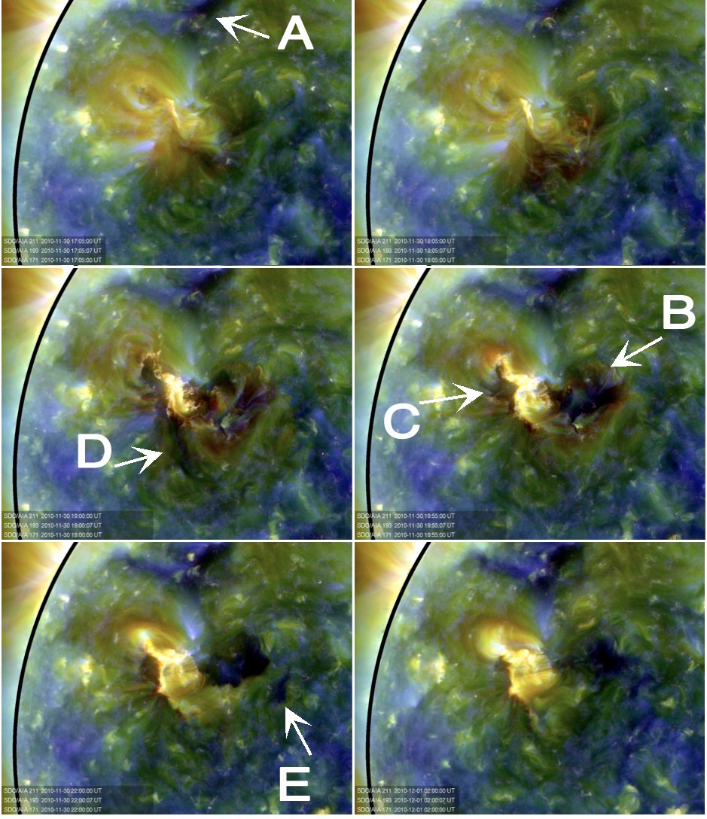
Figure 5. AIA combined wavelength images (Red=211Å, Green=193Å, Blue=171Å) for the dimming/flare/CME event on 2010 November 30 17:05 UT, 18:05 UT , 19:00 UT, 19:55 UT, 22:00 UT, (1 December) 02:00 UT. Areas A - E all exhibited dimming at some point during the event.
Figure 5 shows a series of combined wavelength (Red=211Å, Green=193Å, Blue=171Å) images sampled from 17:05 UT on 2010 November 30 through 2:00 UT 2010 December 1. The first frame, 17:05 UT, is a "pre-event" image, as there is no evidence of the flare and dimming until several minutes later. In Figure 5, we identify several areas that exhibit dimming, including
A: a pre-existing dark region (perhaps coronal hole) that becomes even darker,
B: an area that darkens soon after the flare begins and persists for many hours
C: an area that darkens soon after the flare begins, but is later obscured by flare loops
D: an area that darkens soon after the flare but then "recovers" within a few hours
E: a darkened area that appears relatively late in the timeline, after areas C and D have mostly disappeared
Given the range of times and locations of the many dimming areas, how can one be certain that all of the dimmings are appropriately captured? The traditional method is to perform "base difference" images (Figure 6), where a pre-event image (17:00 UT) is subtracted from each image to highlight only the areas that changed. However, because the different dimming regions grow and recover on different timescales, it is a challenge to combine images from multiple times to capture the full combined extent of all of the dimming regions.
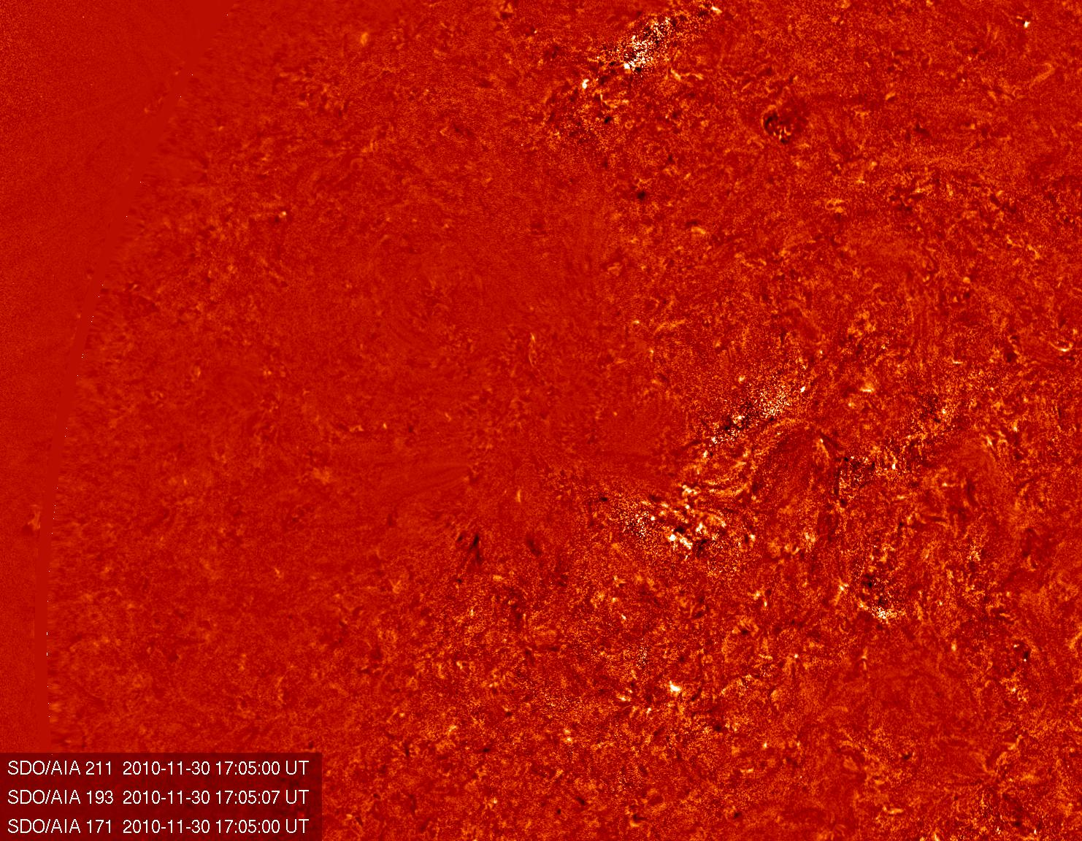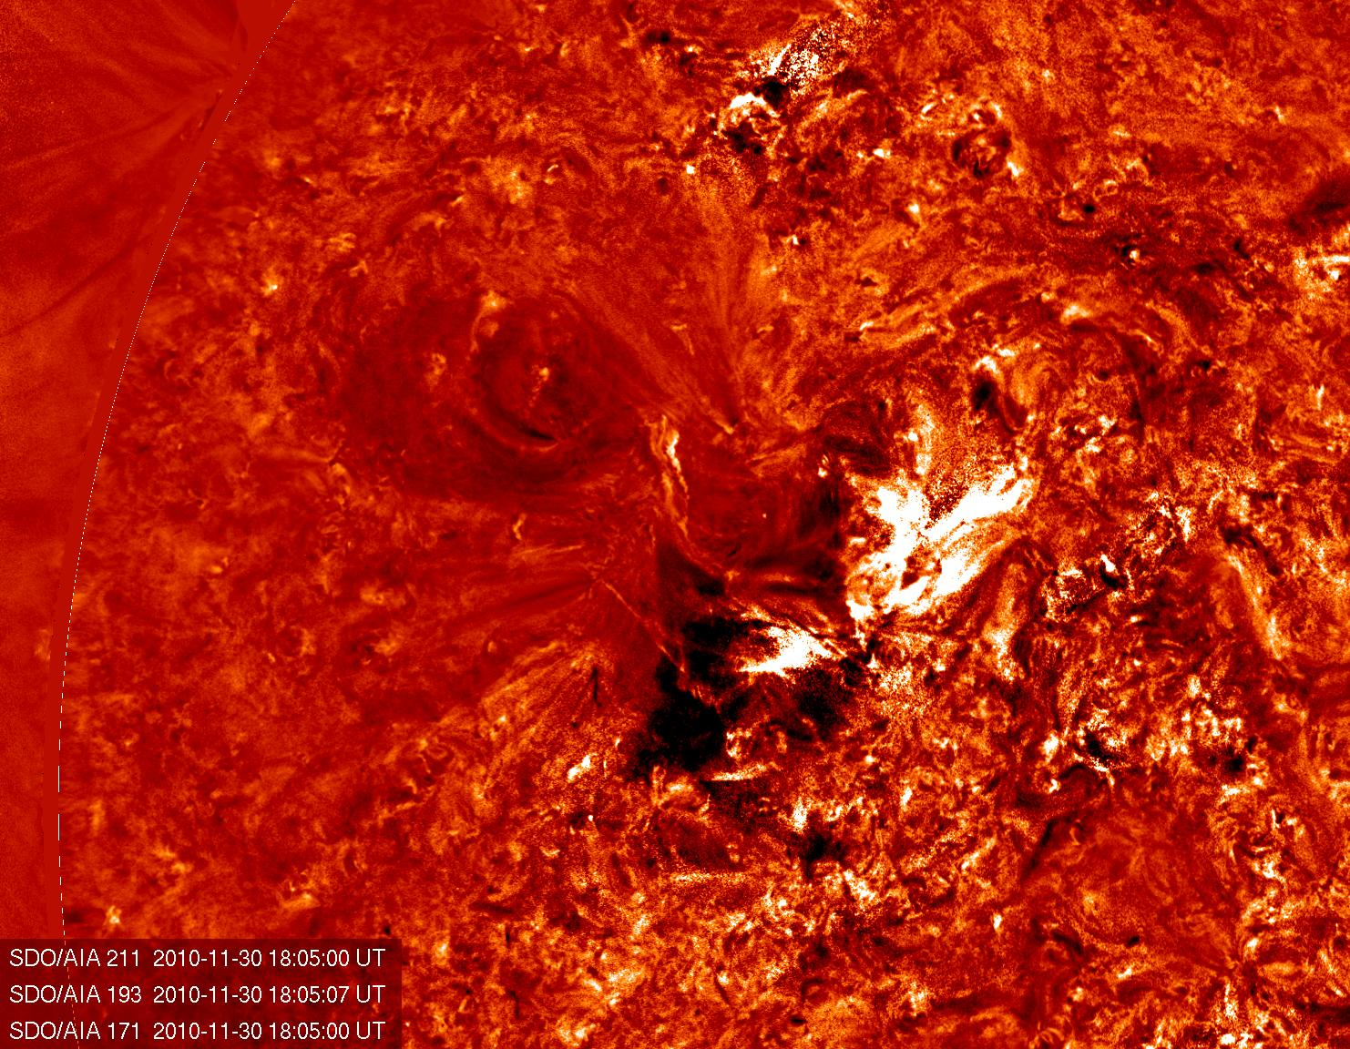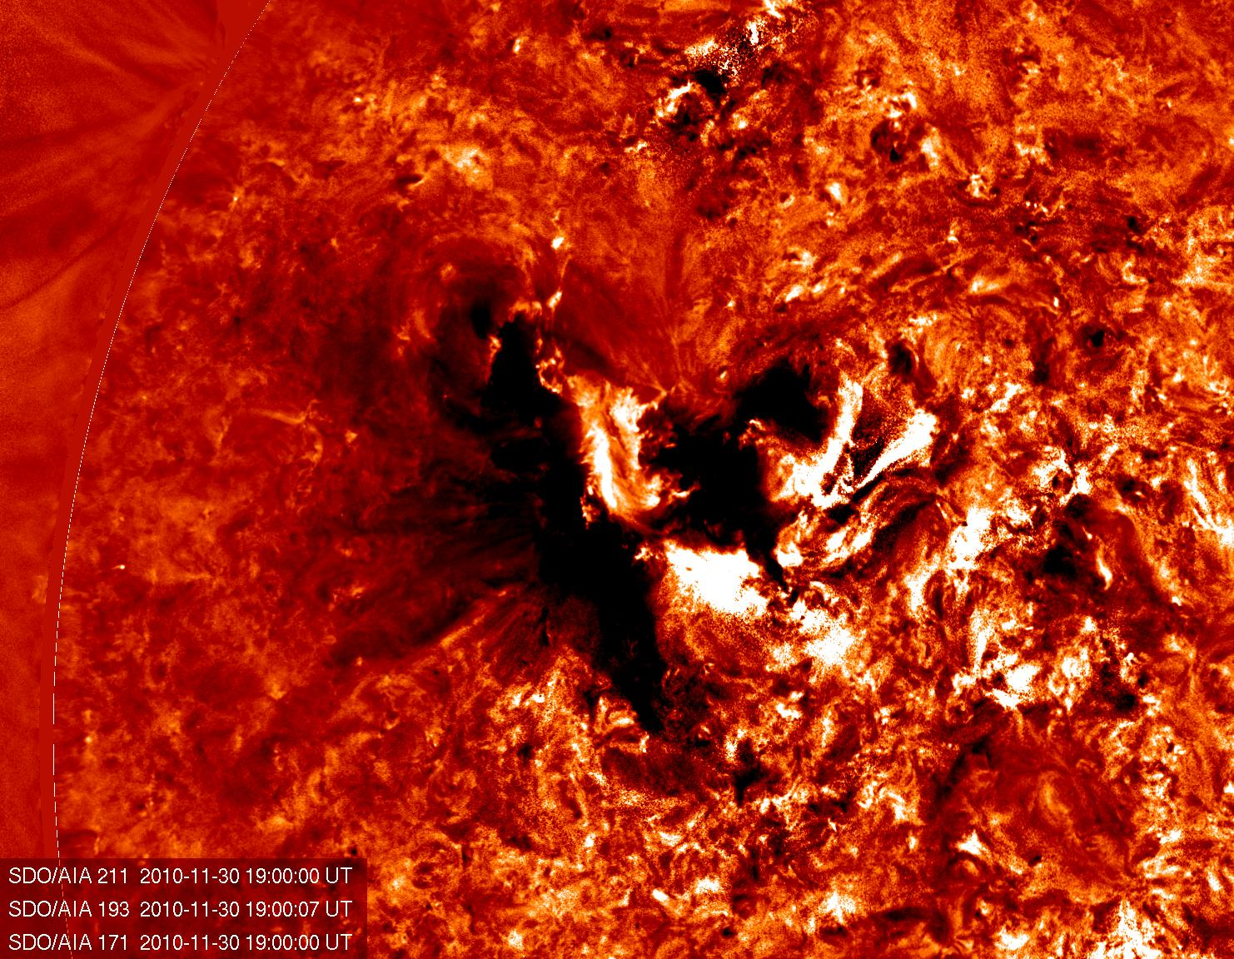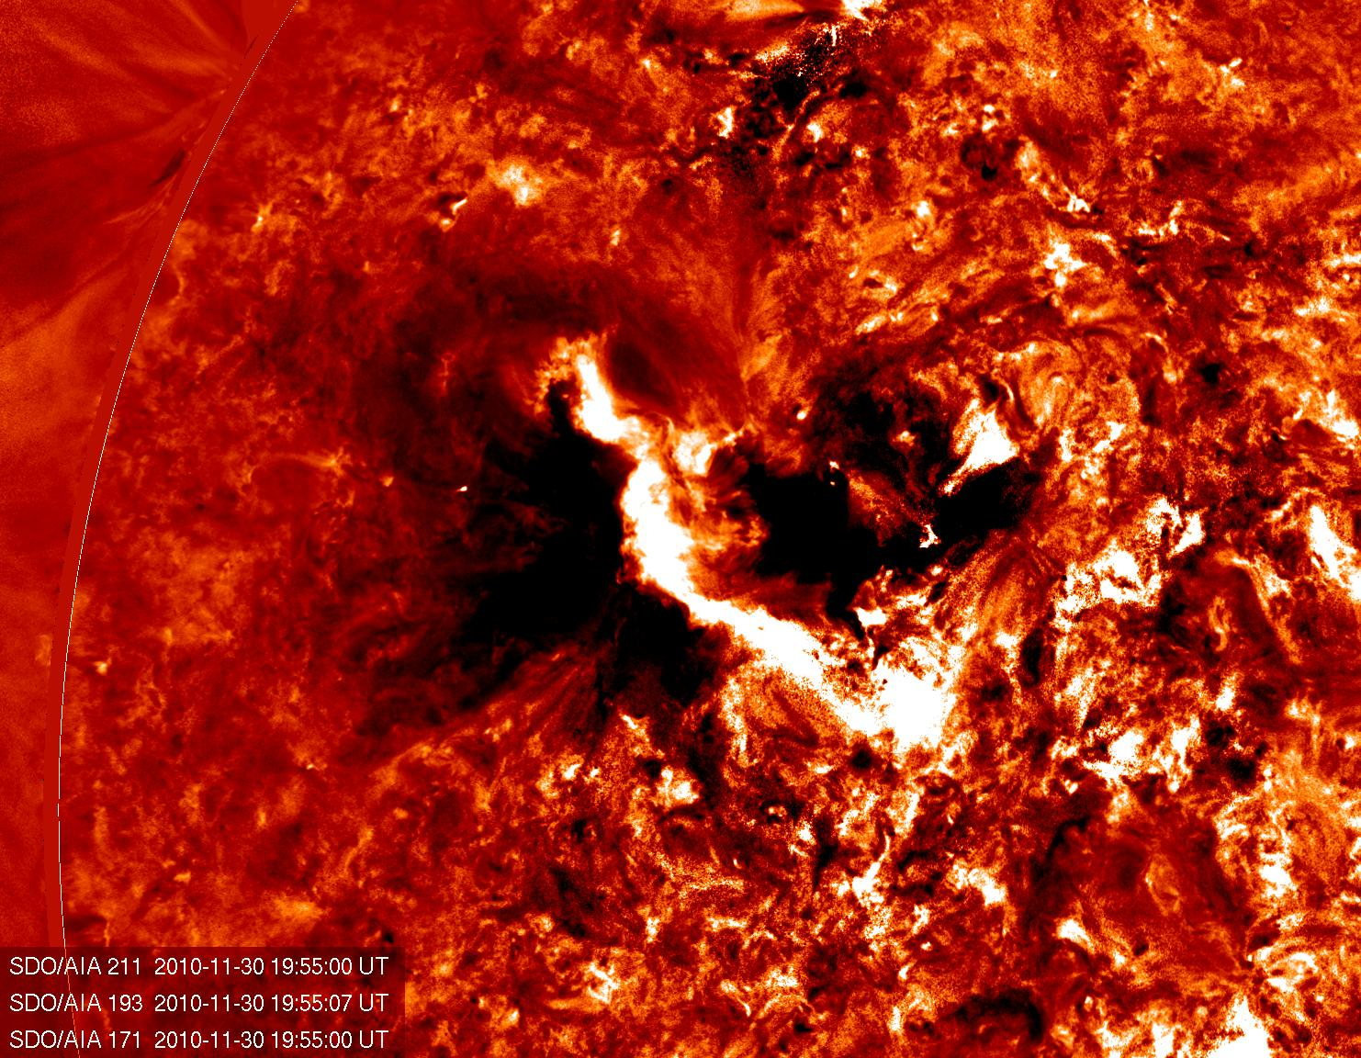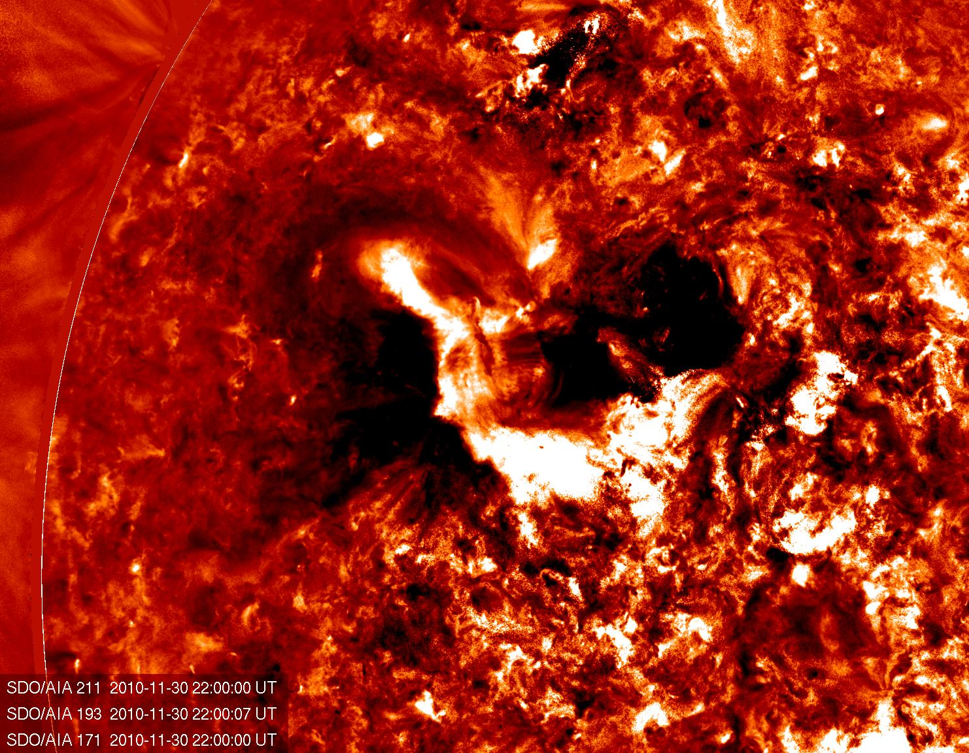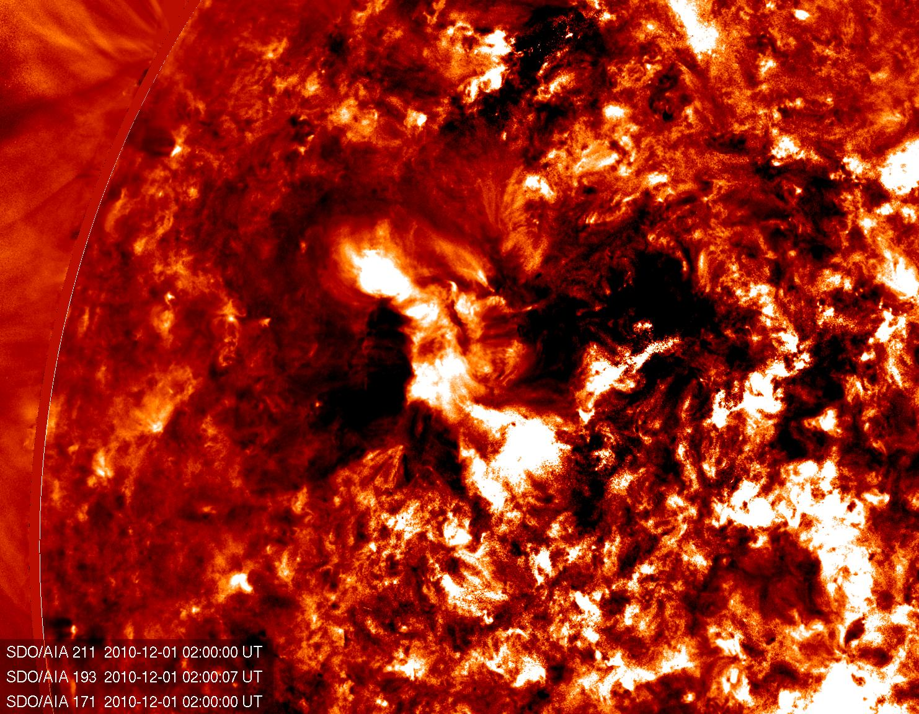
Figure 6. AIA combined wavelength images from Figure 5 with a 17:00 UT "base image" subtracted off.

This event is an excellent candidate for the persistence technique because persistence retains the lowest value over the specified timescale, so even if an image starts to "recover" during the sequence it does not impact subsequent images. Figure 7 shows the same images as Figure 5 and 6, processed with the persistence technique where Q = minimum value for each individual wavelength from t₀< t_{n} ≤t_{N} and t₀ = 2010 November 30 at 17:00 UT. There are several things to note about Figure 7 and the associated movie. First, the flare does not appear at all in the persistence images and movie, because the technique disregards any pixels that do not decrease in emission. The movie shows dimming regions appearing in the complete absence of any associated flaring activity. Second, it is clear from the persistence images that areas C) and D) are in fact one region that evolves inhomogeneously, and that area A) is the only one that is completely disconnected from the other four. This information can also be derived from examination of the base difference images, but the last panel of Figure 7 illustrates how quickly and simply a full dimming map can result from persistence mapping. (Of course, a user who is interested measuring emission from the flare without "contamination" from the dimmings may consider applying Q=maximum to isolate the flare loops).

Note that the off limb is mostly due to prominence
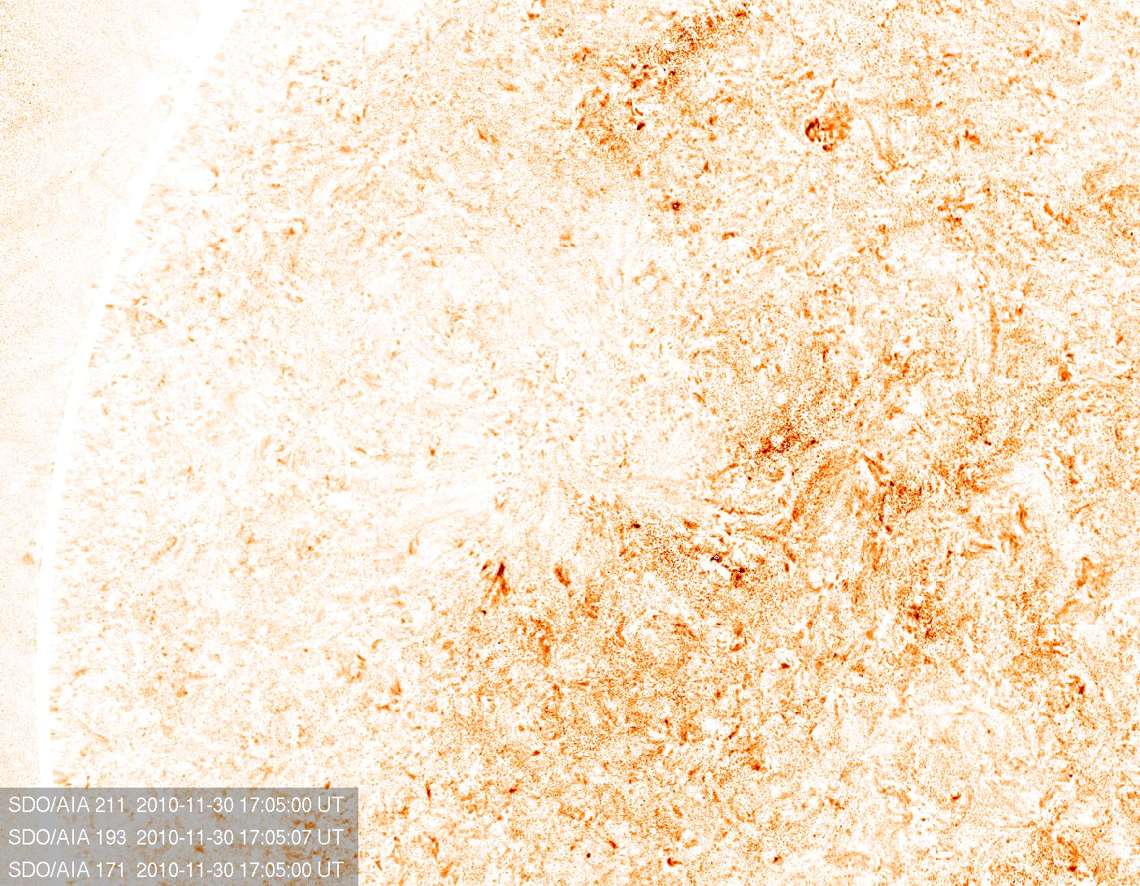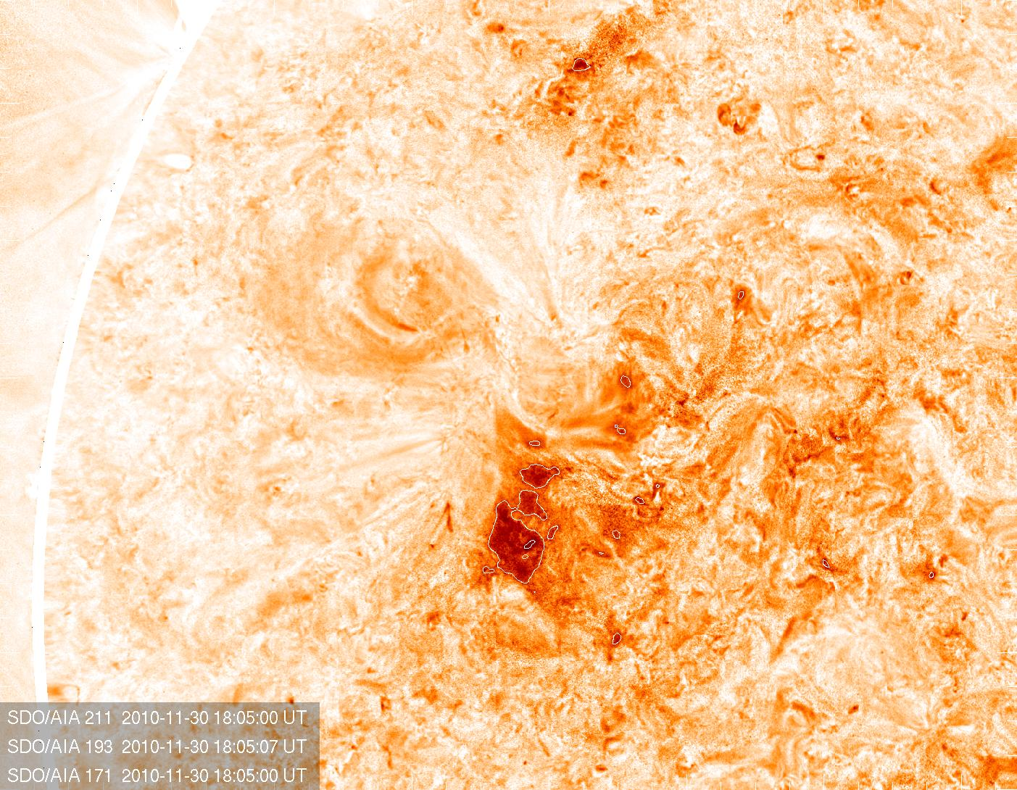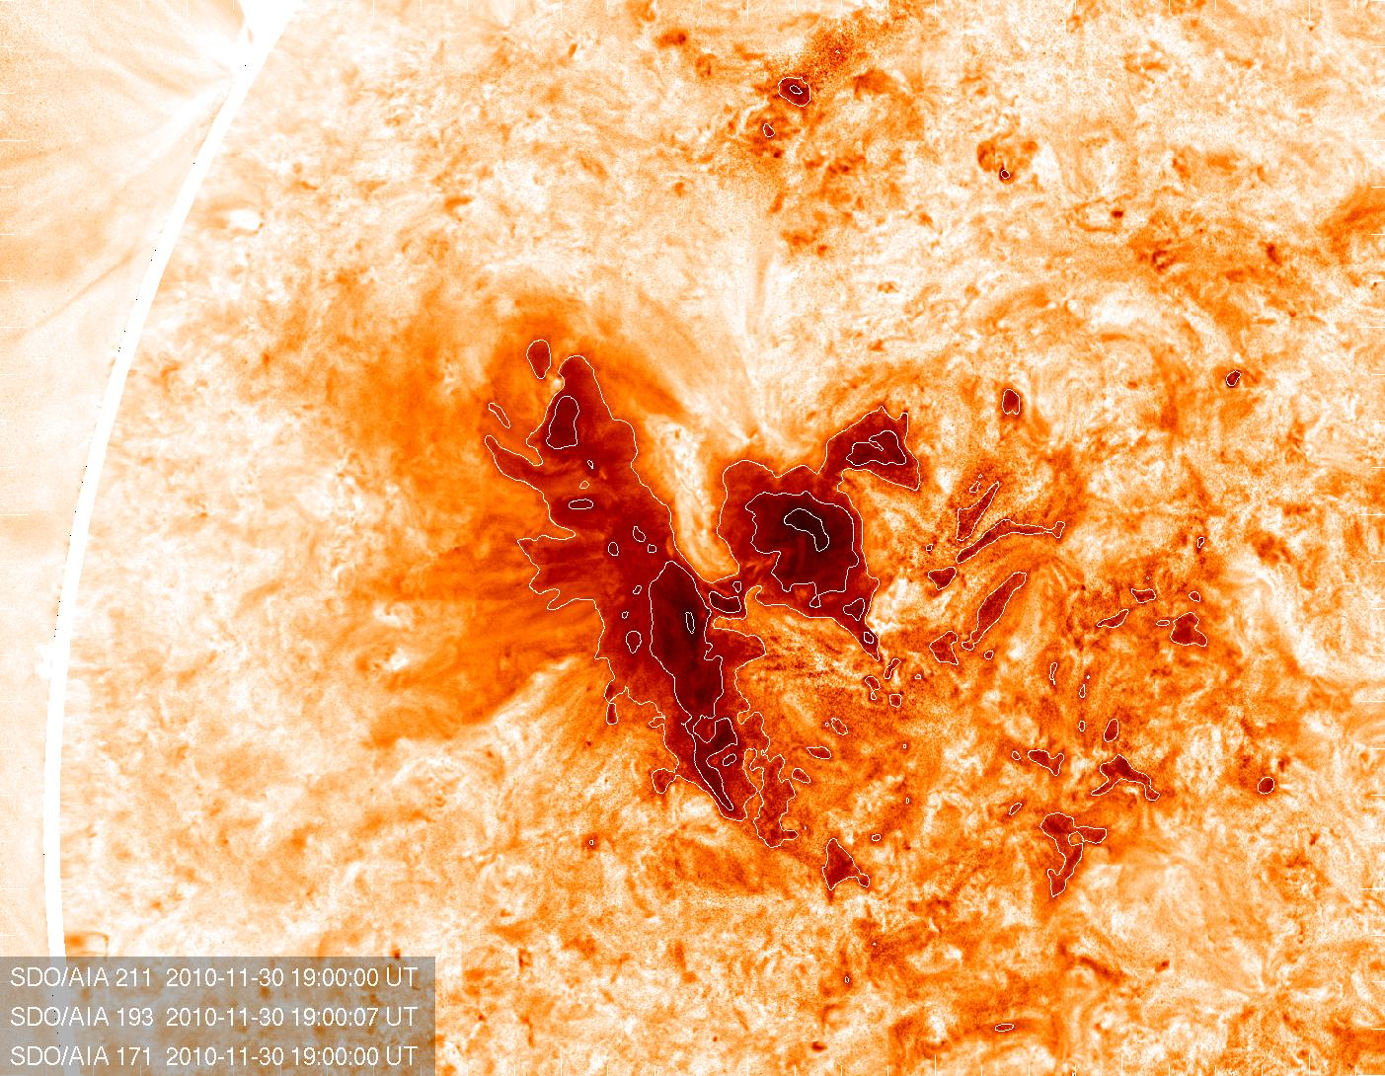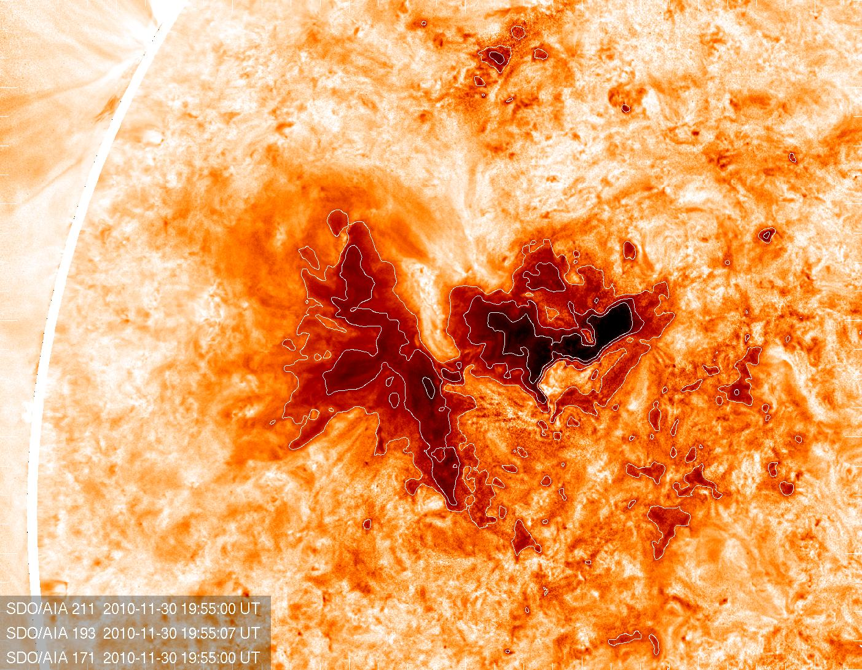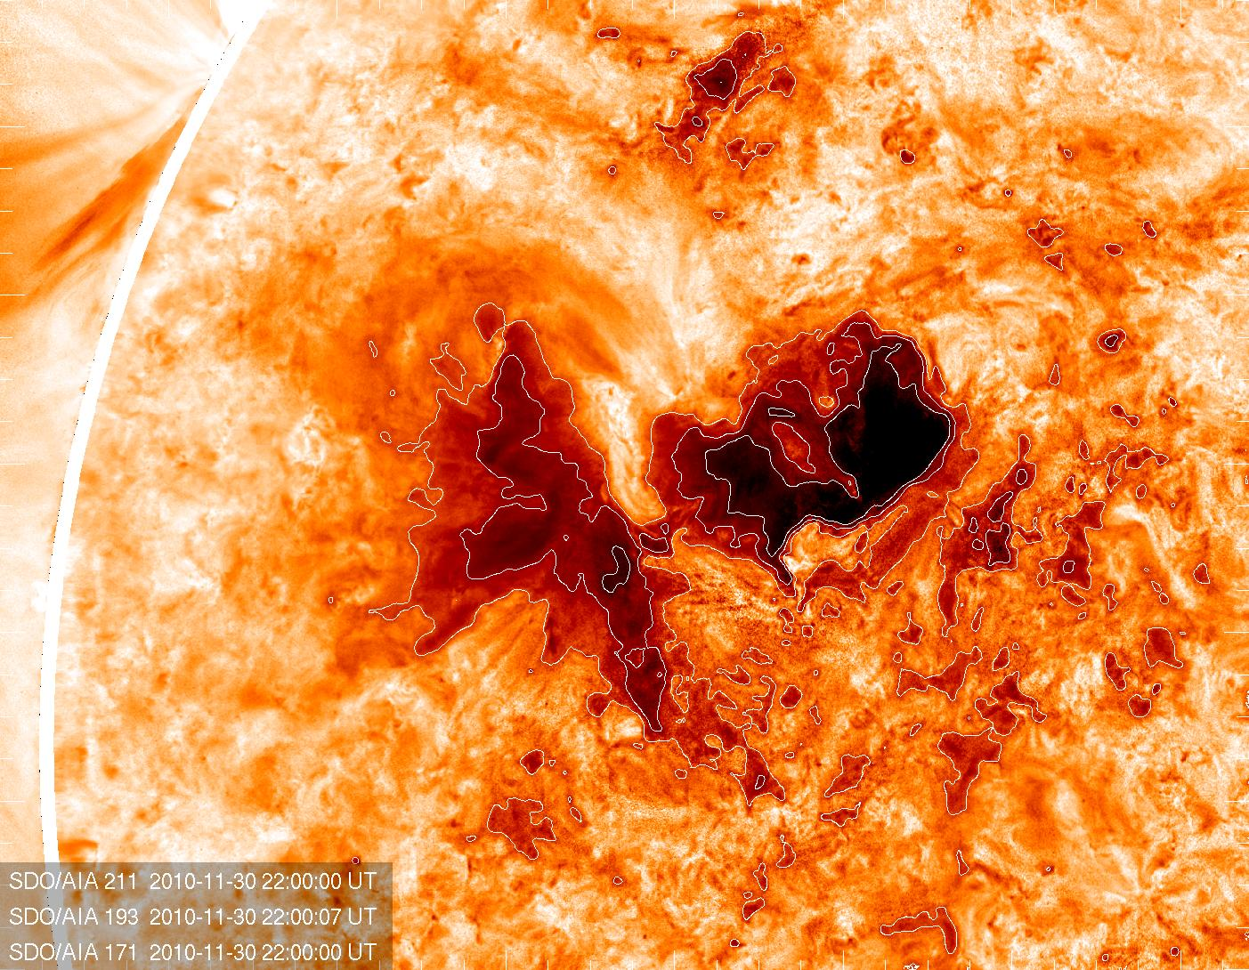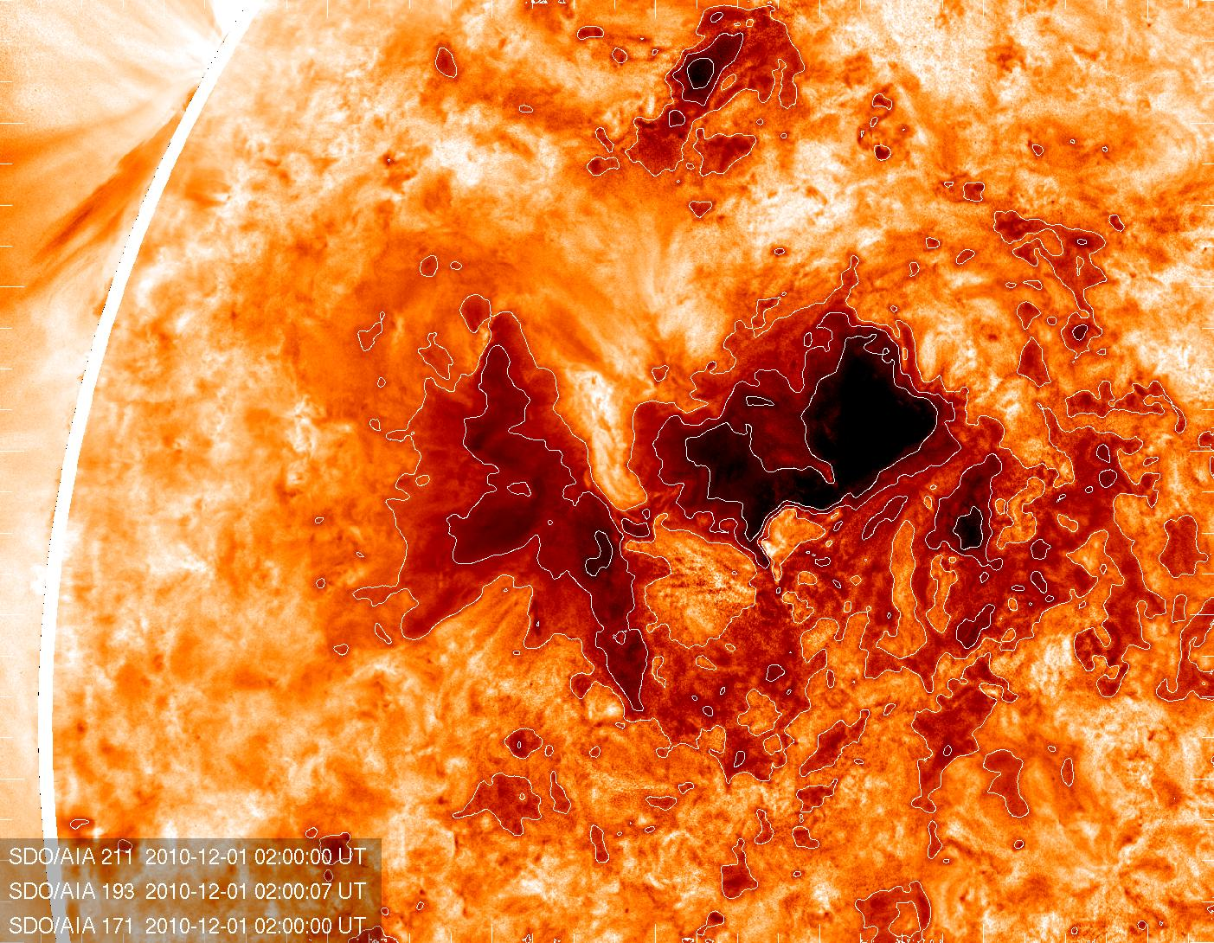
Figure 7. AIA combined wavelength images processed with the persistence technique. Each wavelength was processed independently using the persistence technique, with Q = minimum value per wavelength from t₀< t_{n} ≤t_{N} and t₀ = 2010 November 30 at 17:00 UT. Contours outline quadratic intensity.

2.c. Minimum value Persistence Mapping of an intermittent feature: Erupting prominence
Our final example details a rapidly evolving phenomenon: falling prominence material viewed in absorption against the bright corona. Figure 8 and the accompanying movie clearly shows a large prominence on 2011 June 7 that erupts, but a large fraction of the erupting material falls back to the Sun (Reale et al., 2013, Gilbert et al., 2013). The challenge of measuring and analyzing the falling material is complicated by the fact that the overall shape is continually evolving, and individual features are not easily distinguished within the large moving mass.
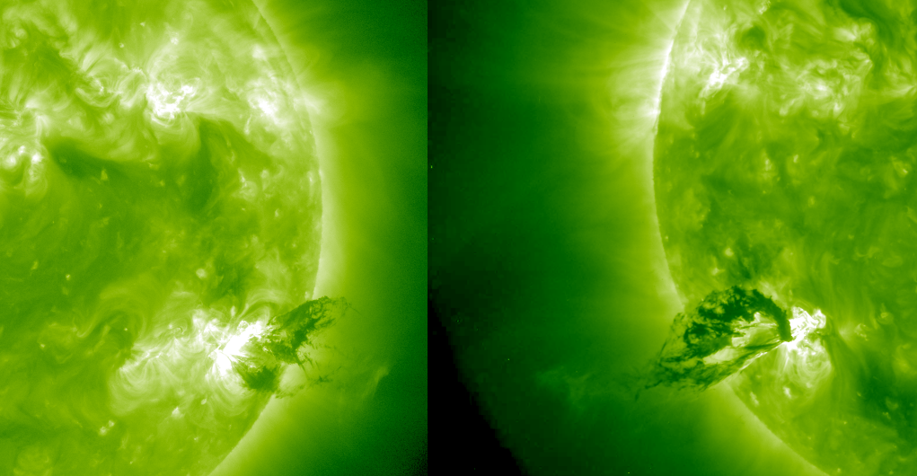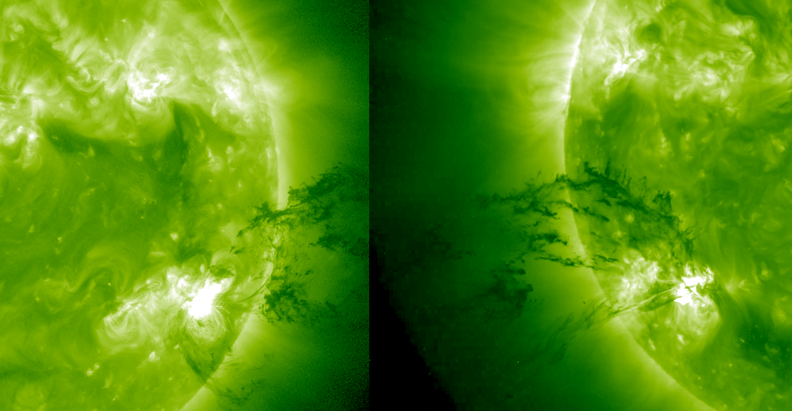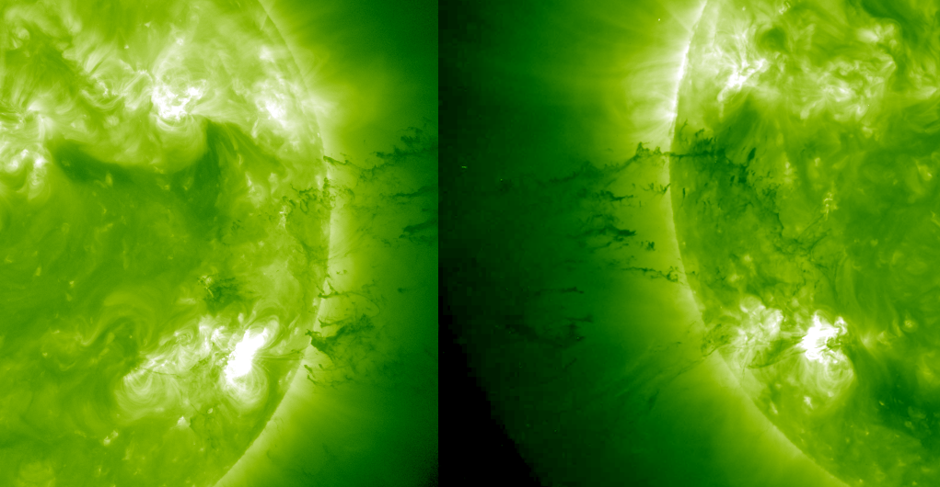
Figure 8.

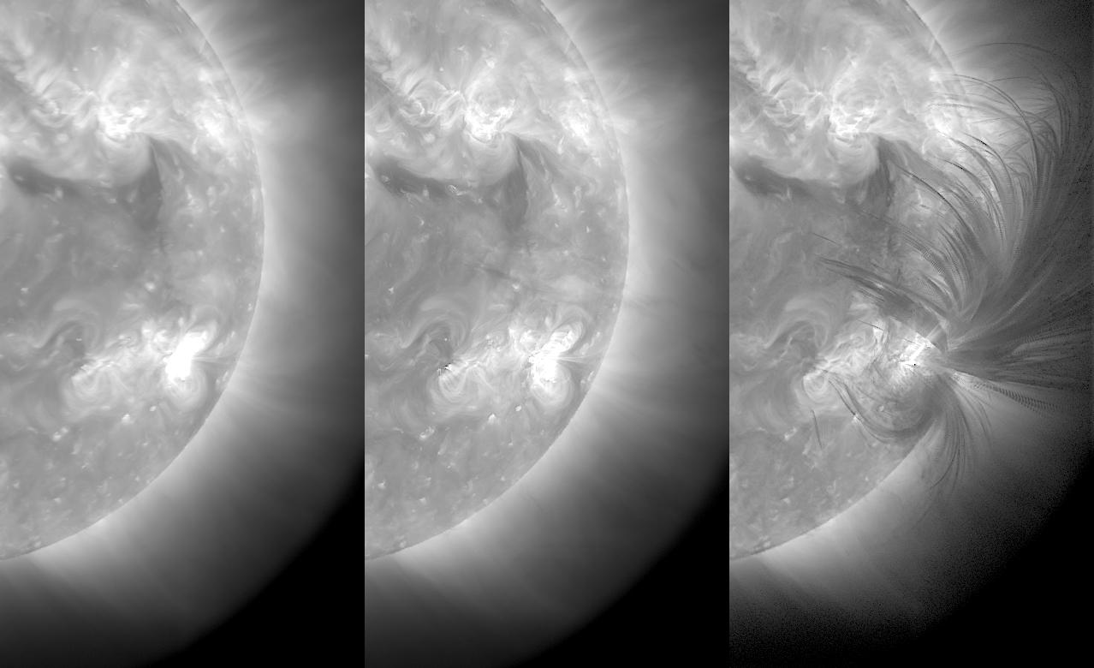
Figure 9.

06:30:19 UT - 7:59:55 UT
In Figure 9 we apply the Q=minimum technique for the 2011 June 7 eruption as seen by AIA in 193 Å, sampling with the maximum image cadence (12 seconds) with Q=minimum and t₀=2011 June 7 05:00:07 UT. In this case, the persistence map is able to highlight the various trajectories exhibited by different parts of the prominence. However, the prominence eventually traverses a large fraction of the visible area, and it becomes difficult to distinguish one trajectory from another.
It is important to distinguish persistence methods from "integration" or "averaging," which are also common ways of combining information from a large number of images. The bottom panel in Figure 4 shows the average value per pixel over the sample period. Rather than clearly isolating the desired bright features, they simply contribute to the average value of 81 images. While the persistence technique isolates a single value and excludes the other 80, averaging produces a less optimal result. Of course, each situation requires a careful consideration of which technique will work best; there are cases where averaging and integration will produce a more ideal result than persistence, such as a collection of individual images with low signal. Persistence may tend to pick out the noise in low-signal images, making it a poor choice of processing method.
This is example is useful because it illustrates how the timing and cadence can be chosen to optimize the resultant map. A 12-second cadence was not ideal because the location of the prominence did change significantly from one frame to the next. Additionally, choosing a long sequence of images is not optimal when multiple trajectories overlap; by fine-tuning t₀ and the sampling time we can isolate individual trajectories more clearly.
In Figure 10 we apply the Q=minimum technique, but instead of sampling with the maximum image cadence (12 seconds), we sample every two minutes, i.e. t₀< t_{n} ≤t_{N} where n = multiples of 10 and t₀ = 05:00:07 UT.

Figure 10.
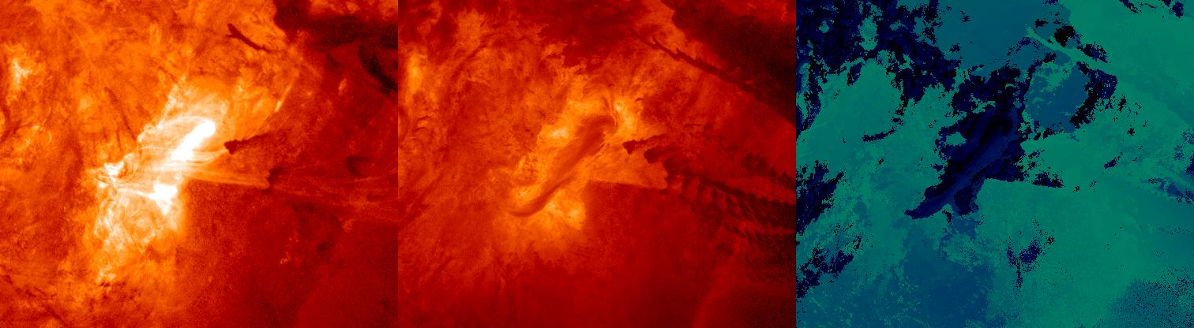
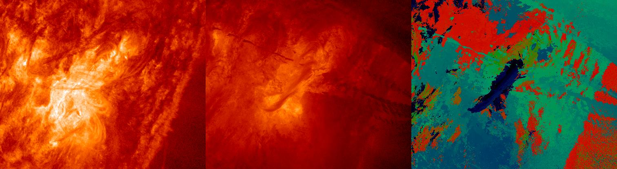
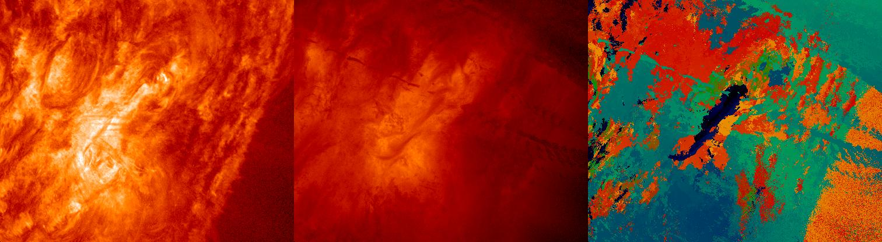
Figure 11. 7 hours of AIA 304 Å images from 2011 June 7. Middle frame is persistence, right frame is time the persistence value was reached (black=05:00 UT, yellow=12:00 UT)

3. DISCUSSION AND CONCLUSIONS
This technique, while being extremely simple to implement, provides a concise and elegant way to capture the evolution of various solar phenomena. As shown in the examples, the choice of persistence function Q and sample timing can be tailored to produce a desired result. The persistence technique differs from "long exposure" or "integration" because the latter techniques do not exclude "unwanted" data points. While an integration of 100 images results in 100 values counting equally, the persistence technique completely exclude 99 of the images, retaining only the one value that satisfies the Q criterion. Persistence maps typically are more distinct and it is easier to identify individual features.

There are several features of persistence maps that the first image; 50% change if random. 100th image: 1% chance of change.

The authors are interested in identifying new applications for the persistence mapping technique. We encourage the reader to check http://sipwork.org/persistence for updated examples and discussion.

If there are 100 images, you use only the 1% you want.
Good when most of the images have no data or stuff you want to throw away- average its bad.
This can be used for lots of useful stuff.
As with most methods, artifacts can be misleading so always view with original images.
Easy pre-processing step for more sophisticated algorithms.
Clearly applicable for more than EUV
Cadence - sometimes sampling smaller is better.

REFERENCES
D. R. Fredkin, J. A. Rice, D. Colquhoun and A. J. Gibb, 1995, "Persistence: A New Statistic for Characterizing Ion-Channel Activity," Philosophical Transactions: Biological Sciences, Vol. 350, No. 1334, 353
C. J. Schrijver et al., 2012, "Destruction of Sun-Grazing Comet C/2011 N3 (SOHO) Within the Low Solar Corona," Science 335, 324
DOI: 10.1126/science.1211688

